# CCET 3680 Mill Lesson 5 Second Exercise

I. Wireframe:

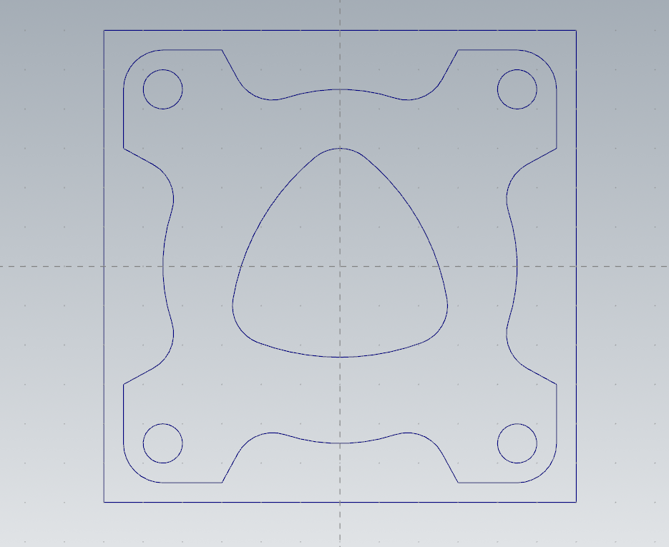

II. Dimensions:

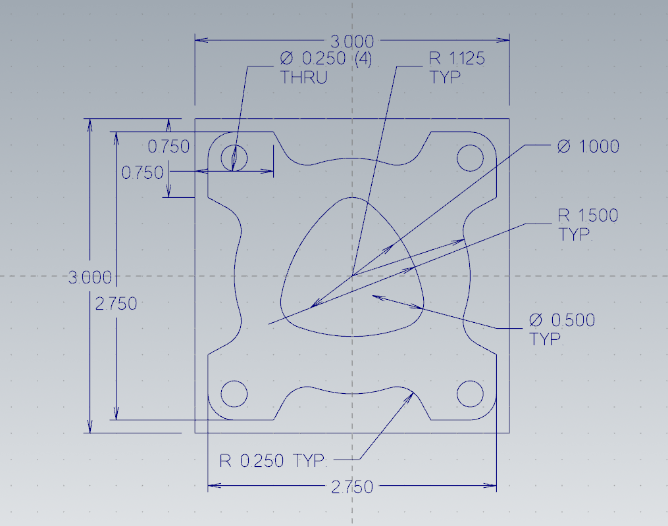

III. Solid:

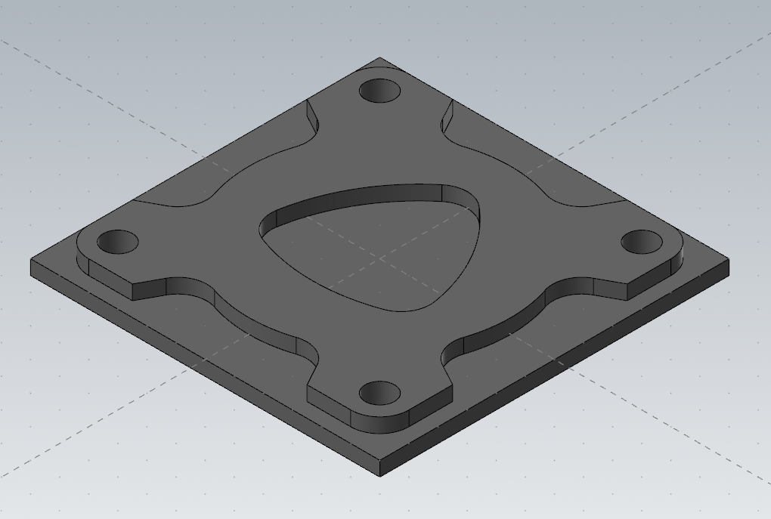

IV. Toolpaths:

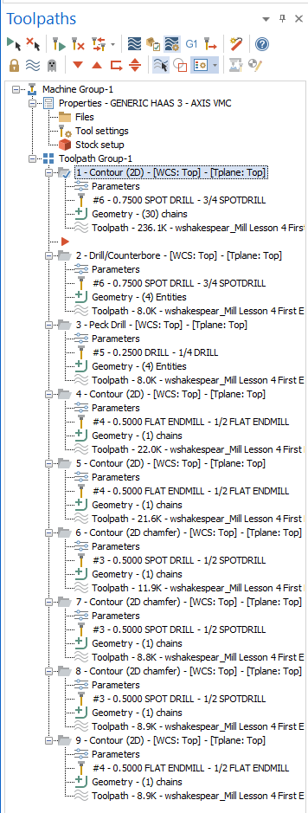

V. Name 2D Contour:

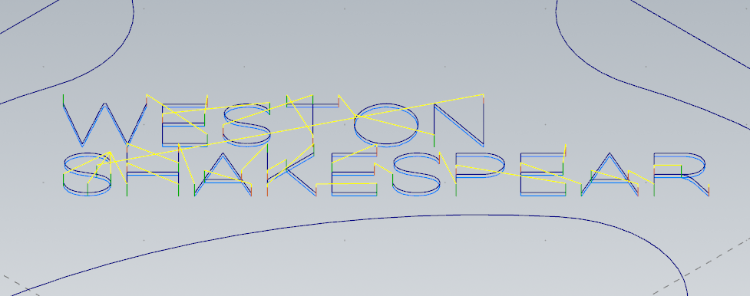

VI. Spot Drill:

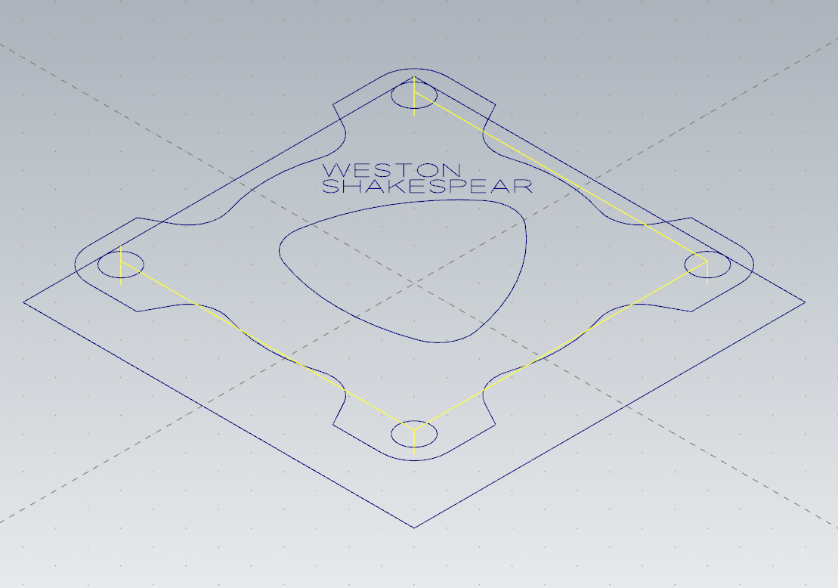

VII. Peck Drill:

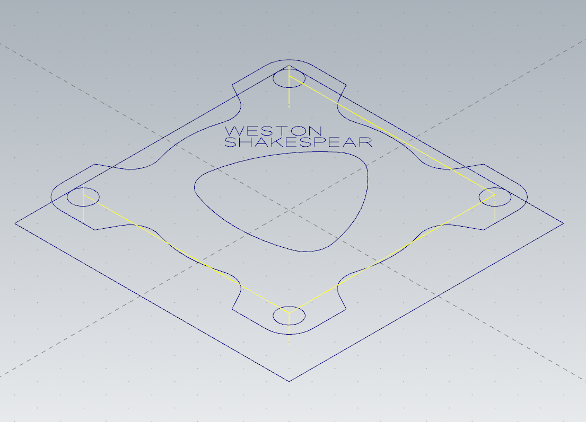

VIII. 2D Contour Outside:

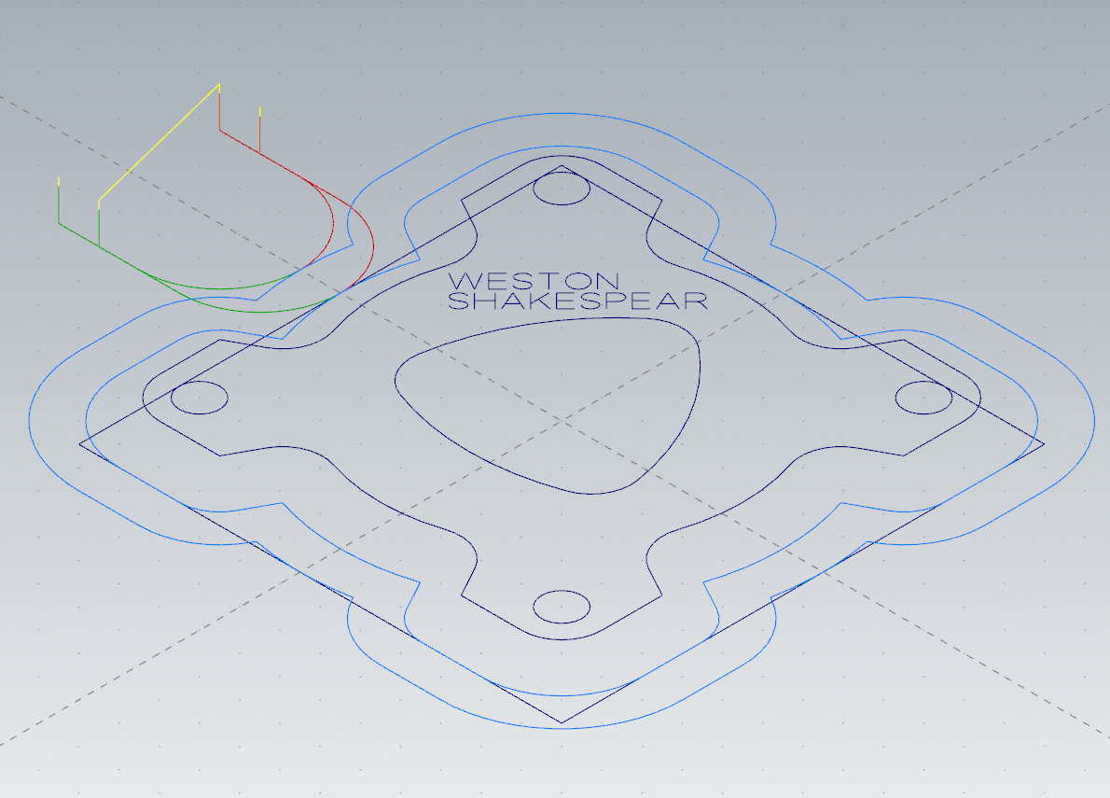

IX. 2D Contour Inside:

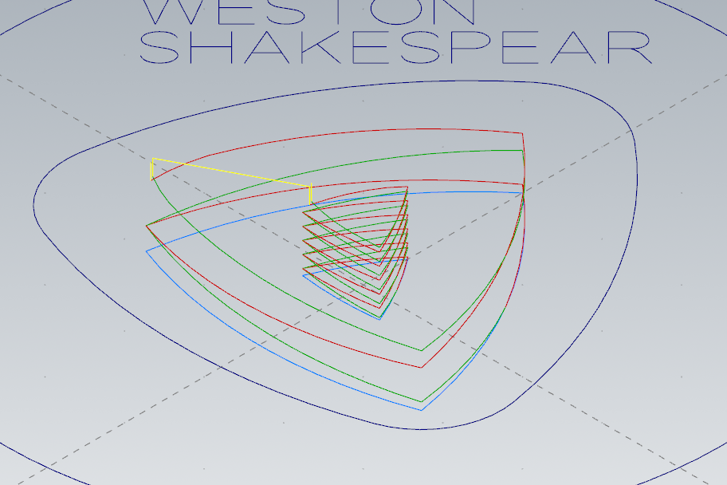

X. 2D Chamfer Contour Outside:

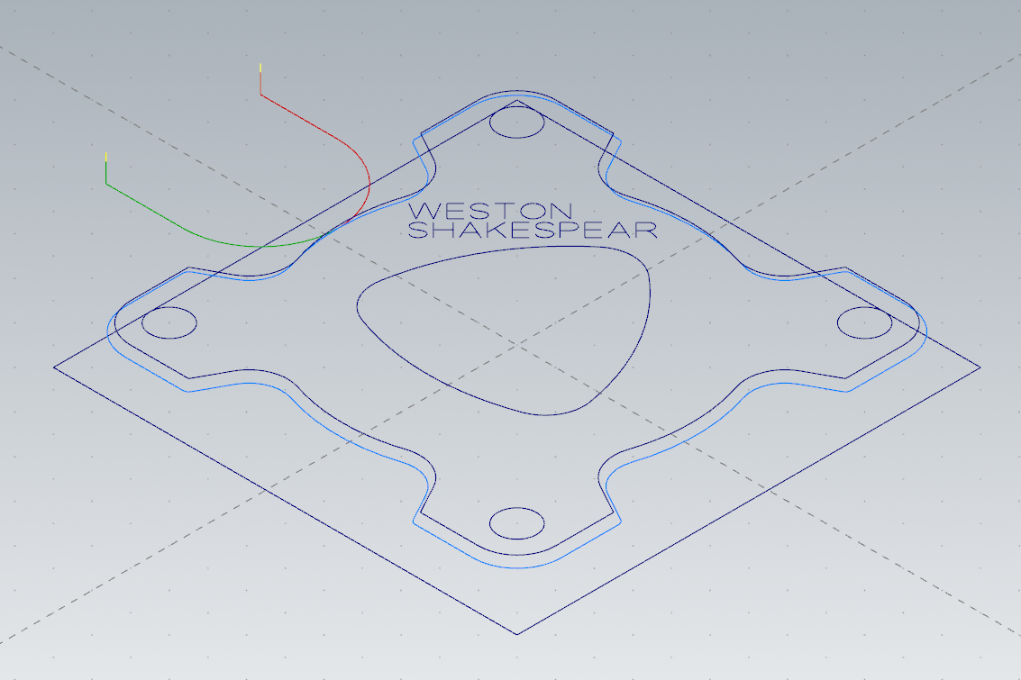

XI. 2D Chamfer Contour Inside:

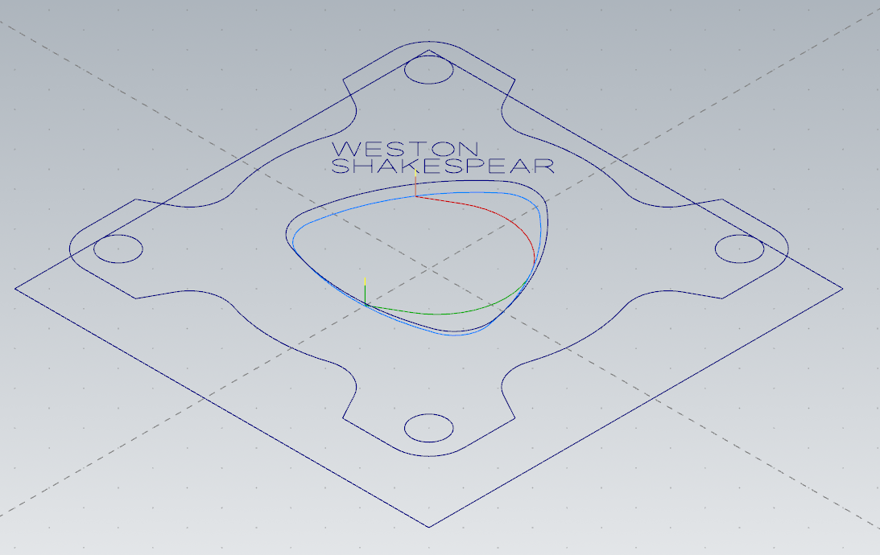

XII: 2D Chamfer Contour:

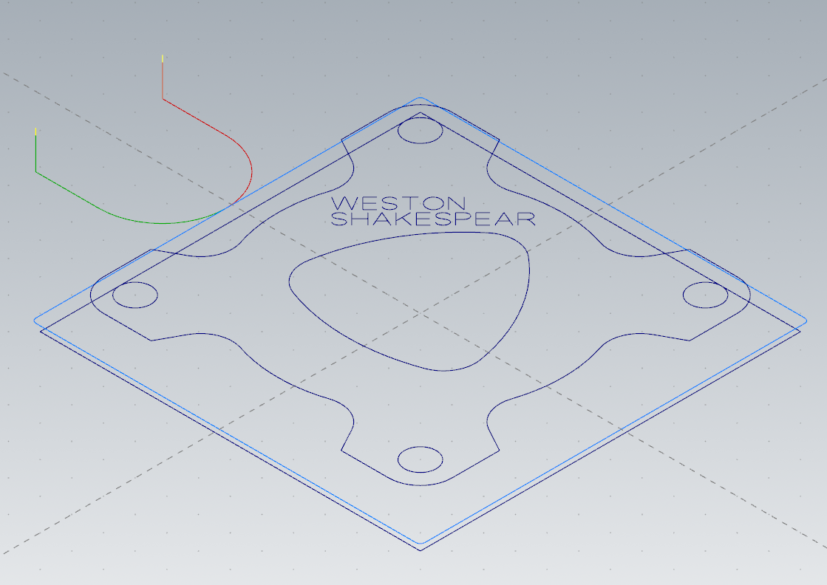

XIII: 2D Contour:

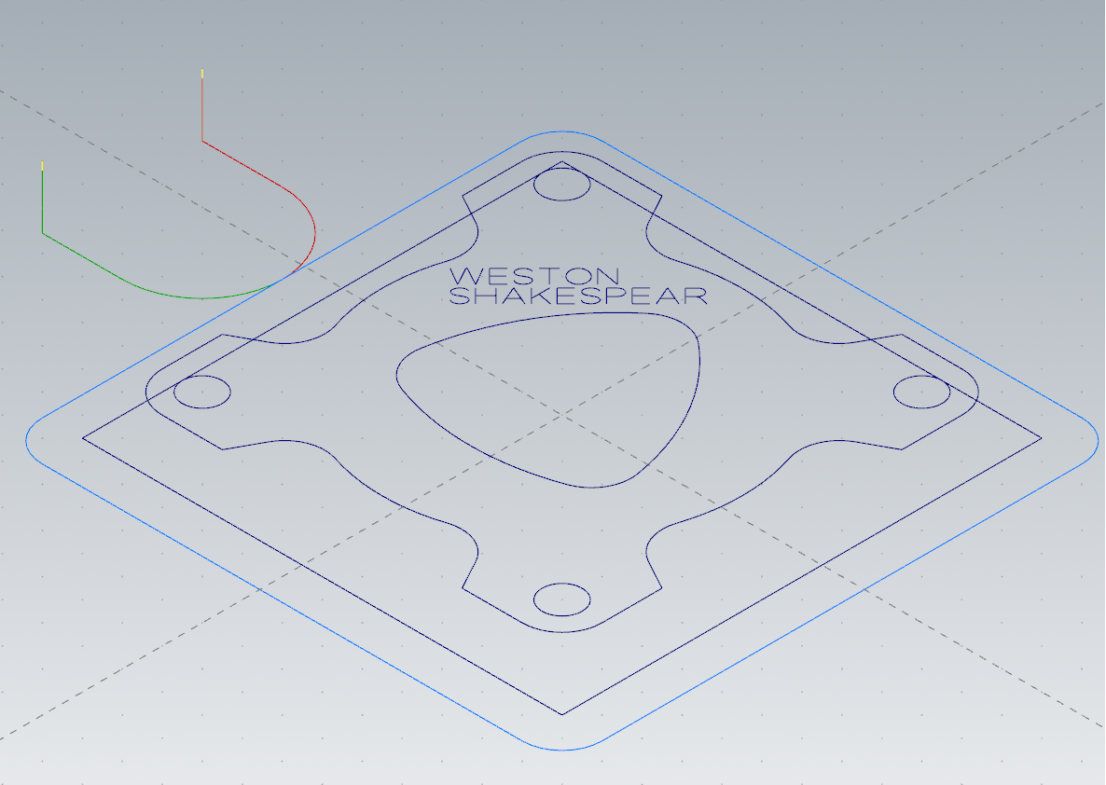

XIV. Final Solid:

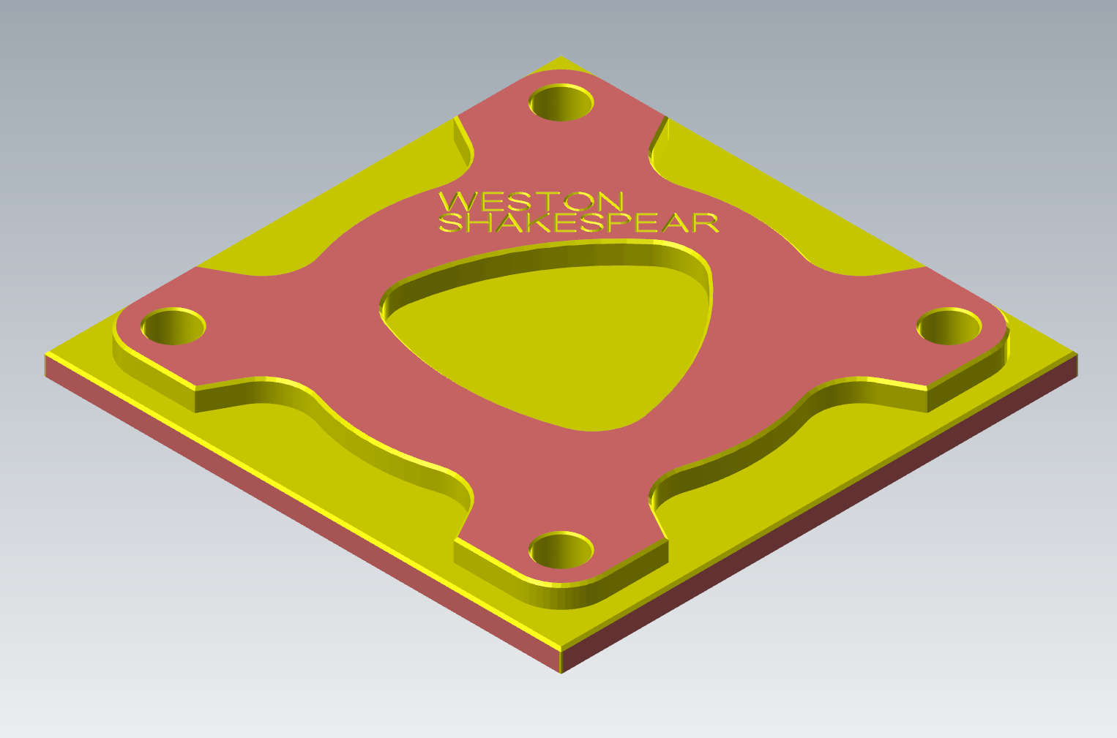

XV. Method:

I just used a basic center anchored rectangle for the perimeter of the geometry. For the wireframe in the center I first created the inner circle then drew a line and manually assigned 30 degrees to the angle, this let me create the equidistant triangle in the center, from there I drew the 3 circles and then used the tangent 2 entities to complete the center.

Then I drew one copy of the radially symmetric portion and used a polar copy to finish the wireframe.

XIV. GCode Changes

To modify my gcode to be compatible with the machine I first made sure the HAAS 3 axis post processor was selected when exporting the gcode. Then I removed the long lines at the beginning and edited the last G28 home command to not zero the x axis.

XV. Gcode:

%

O33001

(WSHAKESPEAR_MILL LESSON 5 SECOND)

(DATE=DD-MM-YY - 30-01-23 TIME=HH:MM - 12:05)

(MCAM FILE - C:\USERS\WESTONSHAKESPEAR\DOWNLOADS\WSHAKESPEAR_MILL LESSON 5B.EMC)

(NC FILE - F:\CCET3680\NC\WSHAKESPEAR_MILL LESSON 5 SECOND.NC)

(MATERIAL - ALUMINUM INCH - 6061)

(T6|3/4 SPOTDRILL|H6|D6|TOOL DIA. - .75)

(T5|1/4 DRILL|H5|D5|TOOL DIA. - .25)

(T4|1/2 FLAT ENDMILL|H4|D4|TOOL DIA. - .5)

(T3|1/2 SPOTDRILL|H3|D3|TOOL DIA. - .5)

N100 G20

N110 G0 G17 G40 G49 G80 G90

N120 T6 M6

N130 G187 P3 E.001

N140 G0 G90 G54 X-1.0209 Y.32 S4966 M3

N150 G43 H6 Z.145

N160 G1 Z.118 F6.4

N170 X-.9097 Y.2562 F500.

N180 X-.9707 Y.3703

N190 X-.9674 Y.3735

N200 X-.8533 Y.3125

N210 X-.9172 Y.4237

N220 Z.138 F6.4

N230 G0 Z.145

N240 X-.7552 Y.4131

N250 G1 Z.118

N260 X-.811 Y.3572 F500.

N270 X-.8961 Y.4423

N280 X-.8403 Y.4982

N290 Z.138 F6.4

N300 G0 Z.145

N310 X-.8028 Y.4542

N320 G1 Z.118

N330 X-.8554 Y.4016 F500.

N340 Z.138 F6.4

N350 G0 Z.145

N360 X-.746 Y.5595

N370 G1 Z.118

N380 X-.7572 Y.5627 F500.

N390 X-.7691 Y.5617

N400 X-.7806 Y.5566

N410 X-.7909 Y.5482

N420 X-.8005 Y.5356

N430 X-.8053 Y.5224

N440 X-.8052 Y.5098

N450 X-.7998 Y.4998

N460 X-.7873 Y.4929

N470 X-.7854 Y.4926

N480 X-.7702 Y.4943

N490 X-.7644 Y.4964

N500 X-.7339 Y.5136

N510 X-.7185 Y.5188

N520 X-.7127 Y.519

N530 X-.7013 Y.5155

N540 X-.6974 Y.5124

N550 X-.6919 Y.5025

N560 X-.6911 Y.4896

N570 X-.6955 Y.476

N580 X-.7055 Y.4628

N590 X-.7156 Y.4547

N600 X-.7267 Y.4494

N610 X-.7379 Y.4478

N620 X-.7476 Y.4497

N630 X-.7562 Y.4535

N640 Z.138 F6.4

N650 G0 Z.145

N660 X-.7089 Y.6295

N670 G1 Z.118

N680 X-.6226 Y.5432 F500.

N690 Z.138 F6.4

N700 G0 Z.145

N710 X-.7414 Y.5971

N720 G1 Z.118

N730 X-.6769 Y.6615 F500.

N740 Z.138 F6.4

N750 G0 Z.145

N760 X-.6145 Y.6384

N770 G1 Z.118

N780 X-.6278 Y.6573 F500.

N790 X-.6283 Y.6585

N800 X-.6335 Y.6804

N810 Y.6809

N820 X-.6309 Y.7007

N830 X-.6303 Y.7028

N840 X-.6204 Y.7196

N850 X-.6182 Y.7219

N860 X-.6018 Y.7327

N870 X-.5996 Y.7335

N880 X-.5799 Y.7368

N890 X-.5776

N900 X-.5566 Y.7322

N910 X-.5552 Y.7316

N920 X-.5363 Y.7189

N930 X-.5352 Y.7178

N940 X-.522 Y.699

N950 X-.5216 Y.698

N960 X-.5164 Y.6757

N970 Y.6756

N980 X-.5194 Y.6543

N990 X-.5197 Y.6536

N1000 X-.5301 Y.6365

N1010 X-.5315 Y.6351

N1020 X-.5463 Y.6246

N1030 X-.5504 Y.6229

N1040 X-.571 Y.6196

N1050 X-.5723 Y.6197

N1060 X-.5945 Y.6248

N1070 X-.5947 Y.6249

N1080 X-.6131 Y.637

N1090 X-.6145 Y.6384

N1100 Z.138 F6.4

N1110 G0 Z.145

N1120 X-.4716 Y.6942

N1130 G1 Z.118

N1140 X-.5592 Y.7817 F500.

N1150 X-.41 Y.7558

N1160 X-.4976 Y.8433

N1170 Z.138 F6.4

N1180 G0 Z.145

N1190 X-.8266 Y.2088

N1200 G1 Z.118

N1210 X-.8571 Y.1916 F500.

N1220 X-.8727 Y.1876

N1230 X-.8781 Y.1877

N1240 X-.8859 Y.1902

N1250 X-.8925 Y.195

N1260 X-.8979 Y.205

N1270 X-.898 Y.2176

N1280 X-.8932 Y.2308

N1290 X-.8836 Y.2434

N1300 X-.8733 Y.2518

N1310 X-.8618 Y.2569

N1320 X-.8499 Y.2579

N1330 X-.8387 Y.2547

N1340 Z.138 F6.4

N1350 G0 Z.145

N1360 X-.7901 Y.2076

N1370 G1 Z.118

N1380 X-.8019 Y.2137 F500.

N1390 X-.8054 Y.2142

N1400 X-.8154 Y.2132

N1410 X-.8266 Y.2088

N1420 X-.8571 Y.1916

N1430 X-.8727 Y.1876

N1440 X-.8781 Y.1877

N1450 X-.8859 Y.1902

N1460 X-.8925 Y.195

N1470 X-.8979 Y.205

N1480 X-.898 Y.2176

N1490 X-.8932 Y.2308

N1500 X-.8836 Y.2434

N1510 X-.8733 Y.2518

N1520 X-.8618 Y.2569

N1530 X-.8499 Y.2579

N1540 X-.8387 Y.2547

N1550 Z.138 F6.4

N1560 G0 Z.145

N1570 X-.7982 Y.158

N1580 G1 Z.118

N1590 X-.7882 Y.1712 F500.

N1600 X-.7838 Y.1848

N1610 X-.7846 Y.1977

N1620 X-.7901 Y.2076

N1630 X-.8019 Y.2137

N1640 X-.8054 Y.2142

N1650 X-.8154 Y.2132

N1660 X-.8266 Y.2088

N1670 X-.8571 Y.1916

N1680 X-.8727 Y.1876

N1690 X-.8781 Y.1877

N1700 X-.8859 Y.1902

N1710 X-.8925 Y.195

N1720 X-.8979 Y.205

N1730 X-.898 Y.2176

N1740 X-.8932 Y.2308

N1750 X-.8836 Y.2434

N1760 X-.8733 Y.2518

N1770 X-.8618 Y.2569

N1780 X-.8499 Y.2579

N1790 X-.8387 Y.2547

N1800 Z.138 F6.4

N1810 G0 Z.145

N1820 X-.8489 Y.1487

N1830 G1 Z.118

N1840 X-.8403 Y.1449 F500.

N1850 X-.8306 Y.1429

N1860 X-.8194 Y.1446

N1870 X-.8082 Y.1499

N1880 X-.7982 Y.158

N1890 X-.7882 Y.1712

N1900 X-.7838 Y.1848

N1910 X-.7846 Y.1977

N1920 X-.7901 Y.2076

N1930 X-.8019 Y.2137

N1940 X-.8054 Y.2142

N1950 X-.8154 Y.2132

N1960 X-.8266 Y.2088

N1970 X-.8571 Y.1916

N1980 X-.8727 Y.1876

N1990 X-.8781 Y.1877

N2000 X-.8859 Y.1902

N2010 X-.8925 Y.195

N2020 X-.8979 Y.205

N2030 X-.898 Y.2176

N2040 X-.8932 Y.2308

N2050 X-.8836 Y.2434

N2060 X-.8733 Y.2518

N2070 X-.8618 Y.2569

N2080 X-.8499 Y.2579

N2090 X-.8387 Y.2547

N2100 Z.138 F6.4

N2110 G0 Z.145

N2120 X-.7479 Y.2059

N2130 G1 Z.118

N2140 X-.8354 Y.2934 F500.

N2150 Z.138 F6.4

N2160 G0 Z.145

N2170 X-.7293 Y.3156

N2180 G1 Z.118

N2190 X-.7935 Y.2515 F500.

N2200 Z.138 F6.4

N2210 G0 Z.145

N2220 X-.6837 Y.27

N2230 G1 Z.118

N2240 X-.7713 Y.3575 F500.

N2250 Z.138 F6.4

N2260 G0 Z.145

N2270 X-.6638 Y.2899

N2280 G1 Z.118

N2290 X-.716 Y.4128 F500.

N2300 X-.5931 Y.3606

N2310 Z.138 F6.4

N2320 G0 Z.145

N2330 X-.6811 Y.3317

N2340 G1 Z.118

N2350 X-.6349 Y.3779 F500.

N2360 Z.138 F6.4

N2370 G0 Z.145

N2380 X-.6606 Y.4682

N2390 G1 Z.118

N2400 X-.5731 Y.3806 F500.

N2410 Z.138 F6.4

N2420 G0 Z.145

N2430 X-.6027 Y.5261

N2440 G1 Z.118

N2450 X-.6026 Y.4102 F500.

N2460 Z.138 F6.4

N2470 G0 Z.145

N2480 X-.6027 Y.4575

N2490 G1 Z.118

N2500 X-.5123 Y.4414 F500.

N2510 Z.138 F6.4

N2520 G0 Z.145

N2530 X-.4381 Y.5181

N2540 G1 Z.118

N2550 X-.494 Y.4622 F500.

N2560 X-.579 Y.5473

N2570 X-.5232 Y.6031

N2580 Z.138 F6.4

N2590 G0 Z.145

N2600 X-.5384 Y.5066

N2610 G1 Z.118

N2620 X-.4857 Y.5592 F500.

N2630 Z.138 F6.4

N2640 G0 Z.145

N2650 X-.4391 Y.5585

N2660 G1 Z.118

N2670 X-.4305 Y.5547 F500.

N2680 X-.4209 Y.5527

N2690 X-.4096 Y.5544

N2700 X-.3985 Y.5596

N2710 X-.3884 Y.5678

N2720 X-.3784 Y.5809

N2730 X-.374 Y.5946

N2740 X-.3748 Y.6074

N2750 X-.3803 Y.6174

N2760 X-.3921 Y.6235

N2770 X-.3956 Y.624

N2780 X-.4056 Y.6229

N2790 X-.4169 Y.6185

N2800 X-.4473 Y.6013

N2810 X-.4629 Y.5973

N2820 X-.4684 Y.5975

N2830 X-.4762 Y.6

N2840 X-.4828 Y.6048

N2850 X-.4881 Y.6148

N2860 X-.4882 Y.6274

N2870 X-.4834 Y.6406

N2880 X-.4738 Y.6532

N2890 X-.4635 Y.6616

N2900 X-.4521 Y.6667

N2910 X-.4401 Y.6677

N2920 X-.4289 Y.6645

N2930 Z.138 F6.4

N2940 G0 Z.145

N2950 X-.3382 Y.6155

N2960 G1 Z.118

N2970 X-.4245 Y.7018 F500.

N2980 X-.3908 Y.7355

N2990 X-.38 Y.7433

N3000 X-.3669 Y.7475

N3010 X-.3533 Y.7465

N3020 X-.3413 Y.7394

N3030 X-.3342 Y.7274

N3040 X-.3332 Y.7139

N3050 X-.3374 Y.7007

N3060 X-.3452 Y.6899

N3070 X-.3789 Y.6562

N3080 Z.138 F6.4

N3090 G0 Z.145

N3100 X-.2031 Y.7531

N3110 G1 Z.118

N3120 X-.259 Y.6972 F500.

N3130 X-.344 Y.7823

N3140 X-.2882 Y.8381

N3150 Z.138 F6.4

N3160 G0 Z.145

N3170 X-.2507 Y.7942

N3180 G1 Z.118

N3190 X-.3033 Y.7416 F500.

N3200 Z.138 F6.4

N3210 G0 Z.145

N3220 X-.1825 Y.7713

N3230 G1 Z.118

N3240 X-.2346 Y.8942 F500.

N3250 X-.1117 Y.842

N3260 Z.138 F6.4

N3270 G0 Z.145

N3280 X-.1997 Y.8131

N3290 G1 Z.118

N3300 X-.1535 Y.8593 F500.

N3310 Z.138 F6.4

N3320 G0 Z.145

N3330 X-.0917 Y.862

N3340 G1 Z.118

N3350 X-.1779 Y.9482 F500.

N3360 X-.1389 Y.9873

N3370 X-.128 Y.9946

N3380 X-.1157 Y.9978

N3390 X-.1032 Y.996

N3400 X-.0918 Y.9887

N3410 X-.0845 Y.9773

N3420 X-.0825 Y.9647

N3430 X-.0857 Y.9523

N3440 X-.0933 Y.9417

N3450 X-.1323 Y.9026

N3460 Z.138 F6.4

N3470 G0 Z.145

N3480 X-.0983 Y.9366

N3490 G1 Z.118

N3500 X-.0835 Y.9407 F500.

N3510 X-.0682 Y.9397

N3520 X-.0237 Y.93

N3530 Z.138 F6.4

N3540 G0 Z.145

N3550 G187 P3 E.001

N3560 X-1.125 Y1.125 Z.25

N3570 Z.15

N3580 G99 G81 Z-.01 R.15 F246.6

N3590 X1.125

N3600 Y-1.125

N3610 X-1.125

N3620 G80

N3630 Z.25

N3640 M5

N3650 G91 G28 Z0.

N3660 M01

N3670 T5 M6

N3680 G187 P3 E.001

N3690 G0 G90 G54 X-1.125 Y1.125 S2139 M3

N3700 G43 H5 Z.25

N3710 Z.15

N3720 G99 G83 Z-.155 R.15 Q.075 F4.1

N3730 X1.125

N3740 Y-1.125

N3750 X-1.125

N3760 G80

N3770 Z.25

N3780 M5

N3790 G91 G28 Z0.

N3800 M01

N3810 T4 M6

N3820 G187 P3 E.001

N3830 G0 G90 G54 X-2.625 Y-.5 S4966 M3

N3840 G43 H4 Z.25

N3850 Z.2

N3860 G1 Z0. F6.4

N3870 X-2.125 F500.

N3880 G3 X-1.625 Y0. I0. J.5

N3890 G2 X-1.5968 Y.3014 I1.625 J0.

N3900 G1 X-1.6144 Y.3111

N3910 G2 X-1.875 Y.75 I.2394 J.4389

N3920 G1 Y1.125

N3930 G2 X-1.125 Y1.875 I.75 J0.

N3940 G1 X-.75

N3950 G2 X-.3111 Y1.6144 I0. J-.5

N3960 G1 X-.3014 Y1.5968

N3970 G2 X0. Y1.625 I.3014 J-1.5968

N3980 X.3014 Y1.5968 I0. J-1.625

N3990 G1 X.3111 Y1.6144

N4000 G2 X.75 Y1.875 I.4389 J-.2394

N4010 G1 X1.125

N4020 G2 X1.875 Y1.125 I0. J-.75

N4030 G1 Y.75

N4040 G2 X1.6144 Y.3111 I-.5 J0.

N4050 G1 X1.5968 Y.3014

N4060 G2 X1.625 Y0. I-1.5968 J-.3014

N4070 X1.5968 Y-.3014 I-1.625 J0.

N4080 G1 X1.6144 Y-.3111

N4090 G2 X1.875 Y-.75 I-.2394 J-.4389

N4100 G1 Y-1.125

N4110 G2 X1.125 Y-1.875 I-.75 J0.

N4120 G1 X.75

N4130 G2 X.3111 Y-1.6144 I0. J.5

N4140 G1 X.3014 Y-1.5968

N4150 G2 X0. Y-1.625 I-.3014 J1.5968

N4160 X-.3014 Y-1.5968 I0. J1.625

N4170 G1 X-.3111 Y-1.6144

N4180 G2 X-.75 Y-1.875 I-.4389 J.2394

N4190 G1 X-1.125

N4200 G2 X-1.875 Y-1.125 I0. J.75

N4210 G1 Y-.75

N4220 G2 X-1.6144 Y-.3111 I.5 J0.

N4230 G1 X-1.5968 Y-.3014

N4240 G2 X-1.625 Y0. I1.5968 J.3014

N4250 G3 X-2.125 Y.5 I-.5 J0.

N4260 G1 X-2.625

N4270 Z.2 F6.4

N4280 G0 Z.25

N4290 X-2.375 Y-.5

N4300 Z.2

N4310 G1 Z0.

N4320 X-1.875 F500.

N4330 G3 X-1.375 Y0. I0. J.5

N4340 G2 X-1.3067 Y.428 I1.375 J0.

N4350 G1 X-1.4947 Y.5305

N4360 G2 X-1.625 Y.75 I.1197 J.2195

N4370 G1 Y1.125

N4380 G2 X-1.125 Y1.625 I.5 J0.

N4390 G1 X-.75

N4400 G2 X-.5305 Y1.4947 I0. J-.25

N4410 G1 X-.428 Y1.3067

N4420 G2 X0. Y1.375 I.428 J-1.3067

N4430 X.428 Y1.3067 I0. J-1.375

N4440 G1 X.5305 Y1.4947

N4450 G2 X.75 Y1.625 I.2195 J-.1197

N4460 G1 X1.125

N4470 G2 X1.625 Y1.125 I0. J-.5

N4480 G1 Y.75

N4490 G2 X1.4947 Y.5305 I-.25 J0.

N4500 G1 X1.3067 Y.428

N4510 G2 X1.375 Y0. I-1.3067 J-.428

N4520 X1.3067 Y-.428 I-1.375 J0.

N4530 G1 X1.4947 Y-.5305

N4540 G2 X1.625 Y-.75 I-.1197 J-.2195

N4550 G1 Y-1.125

N4560 G2 X1.125 Y-1.625 I-.5 J0.

N4570 G1 X.75

N4580 G2 X.5305 Y-1.4947 I0. J.25

N4590 G1 X.428 Y-1.3067

N4600 G2 X0. Y-1.375 I-.428 J1.3067

N4610 X-.428 Y-1.3067 I0. J1.375

N4620 G1 X-.5305 Y-1.4947

N4630 G2 X-.75 Y-1.625 I-.2195 J.1197

N4640 G1 X-1.125

N4650 G2 X-1.625 Y-1.125 I0. J.5

N4660 G1 Y-.75

N4670 G2 X-1.4947 Y-.5305 I.25 J0.

N4680 G1 X-1.3067 Y-.428

N4690 G2 X-1.375 Y0. I1.3067 J.428

N4700 G3 X-1.875 Y.5 I-.5 J0.

N4710 G1 X-2.375

N4720 Z.2 F6.4

N4730 G0 Z.25

N4740 G187 P3 E.001

N4750 X-.1089 Y-.0543

N4760 Z.2

N4770 G3 X.037 Y-.0761 I.1459 J.4783 F500.

N4780 X.0739 Y-.0747 I0. J.5001

N4790 G1 X.0976 Y-.0727 Z.1988

N4800 X.1213 Y-.07 Z.1975

N4810 X.1047 Y-.033 Z.1954

N4820 X.0866 Y.0032 Z.1932

N4830 X.067 Y.0387 Z.1911

N4840 X.046 Y.0734 Z.189

N4850 X.0237 Y.1071 Z.1869

N4860 X0. Y.14 Z.1848

N4870 X-.0283 Y.1005 Z.1822

N4880 X-.0546 Y.0596 Z.1797

N4890 X-.0789 Y.0175 Z.1771

N4900 X-.1011 Y-.0258 Z.1746

N4910 X-.1213 Y-.07 Z.172

N4920 X-.081 Y-.0741 Z.1699

N4930 X-.0405 Y-.0766 Z.1677

N4940 X0. Y-.0774 Z.1656

N4950 X.0405 Y-.0766 Z.1635

N4960 X.081 Y-.0741 Z.1614

N4970 X.1213 Y-.07 Z.1593

N4980 X.1047 Y-.033 Z.1572

N4990 X.0866 Y.0032 Z.155

N5000 X.067 Y.0387 Z.1529

N5010 X.046 Y.0734 Z.1508

N5020 X.0237 Y.1071 Z.1486

N5030 X0. Y.14 Z.1465

N5040 X-.0283 Y.1005 Z.144

N5050 X-.0546 Y.0596 Z.1414

N5060 X-.0789 Y.0175 Z.1389

N5070 X-.1011 Y-.0258 Z.1363

N5080 X-.1213 Y-.07 Z.1338

N5090 X-.081 Y-.0741 Z.1317

N5100 X-.0405 Y-.0766 Z.1295

N5110 X0. Y-.0774 Z.1274

N5120 X.0405 Y-.0766 Z.1253

N5130 X.081 Y-.0741 Z.1232

N5140 X.1213 Y-.07 Z.1211

N5150 X.1047 Y-.033 Z.119

N5160 X.0866 Y.0032 Z.1168

N5170 X.067 Y.0387 Z.1147

N5180 X.046 Y.0734 Z.1126

N5190 X.0237 Y.1071 Z.1104

N5200 X0. Y.14 Z.1083

N5210 X-.0283 Y.1005 Z.1058

N5220 X-.0546 Y.0596 Z.1032

N5230 X-.0789 Y.0175 Z.1007

N5240 X-.1011 Y-.0258 Z.0981

N5250 X-.1213 Y-.07 Z.0956

N5260 X-.081 Y-.0741 Z.0935

N5270 X-.0405 Y-.0766 Z.0913

N5280 X0. Y-.0774 Z.0892

N5290 X.0405 Y-.0766 Z.0871

N5300 X.081 Y-.0741 Z.0849

N5310 X.1213 Y-.07 Z.0828

N5320 X.1047 Y-.033 Z.0807

N5330 X.0866 Y.0032 Z.0786

N5340 X.067 Y.0387 Z.0765

N5350 X.046 Y.0734 Z.0744

N5360 X.0237 Y.1071 Z.0722

N5370 X0. Y.14 Z.0701

N5380 X-.0283 Y.1005 Z.0675

N5390 X-.0546 Y.0596 Z.065

N5400 X-.0789 Y.0175 Z.0624

N5410 X-.1011 Y-.0258 Z.0599

N5420 X-.1213 Y-.07 Z.0573

N5430 X-.081 Y-.0741 Z.0552

N5440 X-.0405 Y-.0766 Z.053

N5450 X0. Y-.0774 Z.0509

N5460 X.0405 Y-.0766 Z.0488

N5470 X.081 Y-.0741 Z.0467

N5480 X.1213 Y-.07 Z.0446

N5490 X.1047 Y-.033 Z.0425

N5500 X.0866 Y.0032 Z.0403

N5510 X.067 Y.0387 Z.0382

N5520 X.046 Y.0734 Z.0361

N5530 X.0237 Y.1071 Z.034

N5540 X0. Y.14 Z.0319

N5550 X-.0283 Y.1005 Z.0293

N5560 X-.0546 Y.0596 Z.0268

N5570 X-.0789 Y.0175 Z.0242

N5580 X-.1011 Y-.0258 Z.0217

N5590 X-.1213 Y-.07 Z.0191

N5600 X-.081 Y-.0741 Z.017

N5610 X-.0405 Y-.0766 Z.0148

N5620 X0. Y-.0774 Z.0127

N5630 X.0405 Y-.0766 Z.0106

N5640 X.081 Y-.0741 Z.0085

N5650 X.1213 Y-.07 Z.0064

N5660 X.1047 Y-.033 Z.0043

N5670 X.0866 Y.0032 Z.0021

N5680 X.067 Y.0387 Z0.

N5690 G3 X0. Y.14 I-.866 J-.5

N5700 X-.1213 Y-.07 I.799 J-.6013

N5710 X0. Y-.0774 I.1213 J.9926

N5720 X.1213 Y-.07 I0. J1.

N5730 X.067 Y.0387 I-.9203 J-.3913

N5740 G1 X.046 Y.0734 Z.0021

N5750 X.0237 Y.1071 Z.0043

N5760 X0. Y.14 Z.0064

N5770 X-.0283 Y.1005 Z.0089

N5780 X-.0546 Y.0596 Z.0115

N5790 X-.0789 Y.0175 Z.014

N5800 X-.1011 Y-.0258 Z.0166

N5810 X-.1213 Y-.07 Z.0191

N5820 X-.081 Y-.0741 Z.0212

N5830 X-.0405 Y-.0766 Z.0234

N5840 X0. Y-.0774 Z.0255

N5850 X.0405 Y-.0766 Z.0276

N5860 X.081 Y-.0741 Z.0298

N5870 X.1213 Y-.07 Z.0319

N5880 X.1047 Y-.033 Z.034

N5890 X.0866 Y.0032 Z.0361

N5900 X.067 Y.0387 Z.0382

N5910 X.046 Y.0734 Z.0403

N5920 X.0237 Y.1071 Z.0425

N5930 X0. Y.14 Z.0446

N5940 X-.0283 Y.1005 Z.0471

N5950 X-.0546 Y.0596 Z.0497

N5960 X-.0789 Y.0175 Z.0522

N5970 X-.1011 Y-.0258 Z.0548

N5980 X-.1213 Y-.07 Z.0573

N5990 X-.081 Y-.0741 Z.0594

N6000 X-.0405 Y-.0766 Z.0616

N6010 X0. Y-.0774 Z.0637

N6020 X.0405 Y-.0766 Z.0658

N6030 X.081 Y-.0741 Z.068

N6040 X.1213 Y-.07 Z.0701

N6050 X.1047 Y-.033 Z.0722

N6060 X.0866 Y.0032 Z.0744

N6070 X.067 Y.0387 Z.0765

N6080 X.046 Y.0734 Z.0786

N6090 X.0237 Y.1071 Z.0807

N6100 X0. Y.14 Z.0828

N6110 X-.0283 Y.1005 Z.0854

N6120 X-.0546 Y.0596 Z.0879

N6130 X-.0789 Y.0175 Z.0905

N6140 X-.1011 Y-.0258 Z.093

N6150 X-.1213 Y-.07 Z.0956

N6160 X-.081 Y-.0741 Z.0977

N6170 X-.0405 Y-.0766 Z.0999

N6180 X0. Y-.0774 Z.102

N6190 X.0405 Y-.0766 Z.1041

N6200 X.081 Y-.0741 Z.1062

N6210 X.1213 Y-.07 Z.1083

N6220 X.1047 Y-.033 Z.1104

N6230 X.0866 Y.0032 Z.1126

N6240 X.067 Y.0387 Z.1147

N6250 X.046 Y.0734 Z.1168

N6260 X.0237 Y.1071 Z.119

N6270 X0. Y.14 Z.1211

N6280 X-.0283 Y.1005 Z.1236

N6290 X-.0546 Y.0596 Z.1262

N6300 X-.0789 Y.0175 Z.1287

N6310 X-.1011 Y-.0258 Z.1313

N6320 X-.1213 Y-.07 Z.1338

N6330 X-.081 Y-.0741 Z.1359

N6340 X-.0405 Y-.0766 Z.1381

N6350 X0. Y-.0774 Z.1402

N6360 X.0405 Y-.0766 Z.1423

N6370 X.081 Y-.0741 Z.1444

N6380 X.1213 Y-.07 Z.1465

N6390 X.1047 Y-.033 Z.1486

N6400 X.0866 Y.0032 Z.1508

N6410 X.067 Y.0387 Z.1529

N6420 X.046 Y.0734 Z.155

N6430 X.0237 Y.1071 Z.1572

N6440 X0. Y.14 Z.1593

N6450 X-.0283 Y.1005 Z.1618

N6460 X-.0546 Y.0596 Z.1644

N6470 X-.0789 Y.0175 Z.1669

N6480 X-.1011 Y-.0258 Z.1695

N6490 X-.1213 Y-.07 Z.172

N6500 X-.081 Y-.0741 Z.1741

N6510 X-.0405 Y-.0766 Z.1763

N6520 X0. Y-.0774 Z.1784

N6530 X.0405 Y-.0766 Z.1805

N6540 X.081 Y-.0741 Z.1827

N6550 X.1213 Y-.07 Z.1848

N6560 X.1047 Y-.033 Z.1869

N6570 X.0866 Y.0032 Z.189

N6580 X.067 Y.0387 Z.1911

N6590 X.046 Y.0734 Z.1932

N6600 X.0237 Y.1071 Z.1954

N6610 X0. Y.14 Z.1975

N6620 X-.0141 Y.1209 Z.1988

N6630 X-.0277 Y.1014 Z.2

N6640 G3 X-.1015 Y-.0672 I.4134 J-.2814

N6650 G0 Z.25

N6660 X-.4255 Y-.2362

N6670 Z.2

N6680 G3 X-.2765 Y-.2964 I.2596 J.4274

N6690 G1 X-.2219 Y-.3075 Z.1971

N6700 X-.1668 Y-.3162 Z.1942

N6710 X-.1114 Y-.3224 Z.1912

N6720 X-.0557 Y-.3261 Z.1883

N6730 X0. Y-.3274 Z.1854

N6740 X.0631 Y-.3258 Z.1821

N6750 X.1261 Y-.321 Z.1788

N6760 X.1888 Y-.313 Z.1755

N6770 X.2509 Y-.3019 Z.1721

N6780 X.3125 Y-.2877 Z.1688

N6790 X.3732 Y-.2703 Z.1655

N6800 X.433 Y-.25 Z.1622

N6810 X.4208 Y-.188 Z.1589

N6820 X.4054 Y-.1268 Z.1556

N6830 X.387 Y-.0664 Z.1523

N6840 X.3655 Y-.007 Z.1489

N6850 X.3411 Y.0513 Z.1456

N6860 X.3137 Y.1082 Z.1423

N6870 X.2835 Y.1637 Z.139

N6880 X.2505 Y.2176 Z.1357

N6890 X.2149 Y.2697 Z.1324

N6900 X.1767 Y.32 Z.1291

N6910 X.136 Y.3683 Z.1258

N6920 X.0929 Y.4145 Z.1225

N6930 X.0475 Y.4584 Z.1192

N6940 X0. Y.5 Z.1159

N6950 X-.0511 Y.4551 Z.1123

N6960 X-.0997 Y.4075 Z.1088

N6970 X-.1456 Y.3573 Z.1052

N6980 X-.1888 Y.3048 Z.1016

N6990 X-.229 Y.2499 Z.0981

N7000 X-.2661 Y.1929 Z.0945

N7010 X-.3001 Y.134 Z.0909

N7020 X-.3309 Y.0733 Z.0873

N7030 X-.3583 Y.0111 Z.0838

N7040 X-.3823 Y-.0526 Z.0802

N7050 X-.4028 Y-.1174 Z.0766

N7060 X-.4197 Y-.1833 Z.0731

N7070 X-.433 Y-.25 Z.0695

N7080 X-.3732 Y-.2704 Z.0662

N7090 X-.3125 Y-.2877 Z.0629

N7100 X-.2509 Y-.3019 Z.0596

N7110 X-.1888 Y-.3131 Z.0563

N7120 X-.1261 Y-.321 Z.053

N7130 X-.0631 Y-.3258 Z.0497

N7140 X0. Y-.3274 Z.0464

N7150 X.0631 Y-.3258 Z.0431

N7160 X.1261 Y-.321 Z.0398

N7170 X.1888 Y-.3131 Z.0365

N7180 X.2509 Y-.3019 Z.0331

N7190 X.3125 Y-.2877 Z.0298

N7200 X.3732 Y-.2704 Z.0265

N7210 X.433 Y-.25 Z.0232

N7220 X.4208 Y-.188 Z.0199

N7230 X.4054 Y-.1268 Z.0166

N7240 X.387 Y-.0664 Z.0133

N7250 X.3655 Y-.007 Z.0099

N7260 X.3411 Y.0513 Z.0066

N7270 X.3137 Y.1082 Z.0033

N7280 X.2835 Y.1637 Z0.

N7290 G3 X0. Y.5 I-1.0825 J-.625

N7300 X-.433 Y-.25 I.799 J-.9613

N7310 X0. Y-.3274 I.433 J1.1726

N7320 X.433 Y-.25 I0. J1.25

N7330 X.2835 Y.1637 I-1.232 J-.2113

N7340 G1 X.2505 Y.2176 Z.0033

N7350 X.2149 Y.2697 Z.0066

N7360 X.1767 Y.32 Z.0099

N7370 X.136 Y.3683 Z.0133

N7380 X.0929 Y.4145 Z.0166

N7390 X.0475 Y.4584 Z.0199

N7400 X0. Y.5 Z.0232

N7410 X-.0511 Y.4551 Z.0268

N7420 X-.0997 Y.4075 Z.0303

N7430 X-.1456 Y.3573 Z.0339

N7440 X-.1888 Y.3048 Z.0374

N7450 X-.229 Y.2499 Z.041

N7460 X-.2661 Y.1929 Z.0446

N7470 X-.3001 Y.134 Z.0481

N7480 X-.3309 Y.0733 Z.0517

N7490 X-.3583 Y.0111 Z.0553

N7500 X-.3823 Y-.0526 Z.0588

N7510 X-.4028 Y-.1174 Z.0624

N7520 X-.4197 Y-.1833 Z.0659

N7530 X-.433 Y-.25 Z.0695

N7540 X-.3732 Y-.2704 Z.0728

N7550 X-.3125 Y-.2877 Z.0761

N7560 X-.2509 Y-.3019 Z.0794

N7570 X-.1888 Y-.3131 Z.0828

N7580 X-.1261 Y-.321 Z.0861

N7590 X-.0631 Y-.3258 Z.0894

N7600 X0. Y-.3274 Z.0927

N7610 X.0631 Y-.3258 Z.096

N7620 X.1261 Y-.321 Z.0993

N7630 X.1888 Y-.3131 Z.1026

N7640 X.2509 Y-.3019 Z.106

N7650 X.3125 Y-.2877 Z.1093

N7660 X.3732 Y-.2704 Z.1126

N7670 X.433 Y-.25 Z.1159

N7680 X.4208 Y-.188 Z.1192

N7690 X.4054 Y-.1268 Z.1225

N7700 X.387 Y-.0664 Z.1258

N7710 X.3655 Y-.007 Z.1291

N7720 X.3411 Y.0513 Z.1324

N7730 X.3137 Y.1082 Z.1357

N7740 X.2835 Y.1637 Z.139

N7750 X.2505 Y.2176 Z.1423

N7760 X.2149 Y.2697 Z.1456

N7770 X.1767 Y.32 Z.1489

N7780 X.136 Y.3683 Z.1523

N7790 X.0929 Y.4145 Z.1556

N7800 X.0475 Y.4584 Z.1589

N7810 X0. Y.5 Z.1622

N7820 X-.0493 Y.4568 Z.1656

N7830 X-.0962 Y.4111 Z.1691

N7840 X-.1407 Y.363 Z.1725

N7850 X-.1826 Y.3126 Z.1759

N7860 X-.2218 Y.2601 Z.1794

N7870 X-.2582 Y.2056 Z.1828

N7880 X-.2917 Y.1493 Z.1863

N7890 X-.3222 Y.0913 Z.1897

N7900 X-.3497 Y.0317 Z.1931

N7910 X-.3739 Y-.0291 Z.1966

N7920 X-.395 Y-.0912 Z.2

N7930 G3 X-.4174 Y-.2393 I.4776 J-.1481

N7940 X-.4173 Y-.2504 I.5 J0.

N7950 G0 Z.25

N7960 M5

N7970 G91 G28 Z0.

N7980 M01

N7990 T3 M6

N8000 G187 P3 E.001

N8010 G0 G90 G54 X-2.16 Y-.5 S4966 M3

N8020 G43 H3 Z.25

N8030 Z.2

N8040 G1 Z.075 F6.4

N8050 X-1.66 F500.

N8060 G3 X-1.16 Y0. I0. J.5

N8070 G2 X-1.1024 Y.3611 I1.16 J0.

N8080 G3 X-1.0917 Y.428 I-.2043 J.0669

N8090 X-1.2037 Y.6167 I-.215 J0.

N8100 G1 X-1.3918 Y.7193

N8110 G2 X-1.41 Y.75 I.0168 J.0307

N8120 G1 Y1.125

N8130 G2 X-1.125 Y1.41 I.285 J0.

N8140 G1 X-.75

N8150 G2 X-.7193 Y1.3918 I0. J-.035

N8160 G1 X-.6167 Y1.2037

N8170 G3 X-.428 Y1.0917 I.1887 J.103

N8180 X-.3611 Y1.1024 I0. J.215

N8190 G2 X0. Y1.16 I.3611 J-1.1024

N8200 X.3611 Y1.1024 I0. J-1.16

N8210 G3 X.428 Y1.0917 I.0669 J.2043

N8220 X.6167 Y1.2037 I0. J.215

N8230 G1 X.7193 Y1.3918

N8240 G2 X.75 Y1.41 I.0307 J-.0168

N8250 G1 X1.125

N8260 G2 X1.41 Y1.125 I0. J-.285

N8270 G1 Y.75

N8280 G2 X1.3918 Y.7193 I-.035 J0.

N8290 G1 X1.2037 Y.6167

N8300 G3 X1.0917 Y.428 I.103 J-.1887

N8310 X1.1024 Y.3611 I.215 J0.

N8320 G2 X1.16 Y0. I-1.1024 J-.3611

N8330 X1.1024 Y-.3611 I-1.16 J0.

N8340 G3 X1.0917 Y-.428 I.2043 J-.0669

N8350 X1.2037 Y-.6167 I.215 J0.

N8360 G1 X1.3918 Y-.7193

N8370 G2 X1.41 Y-.75 I-.0168 J-.0307

N8380 G1 Y-1.125

N8390 G2 X1.125 Y-1.41 I-.285 J0.

N8400 G1 X.75

N8410 G2 X.7193 Y-1.3918 I0. J.035

N8420 G1 X.6167 Y-1.2037

N8430 G3 X.428 Y-1.0917 I-.1887 J-.103

N8440 X.3611 Y-1.1024 I0. J-.215

N8450 G2 X0. Y-1.16 I-.3611 J1.1024

N8460 X-.3611 Y-1.1024 I0. J1.16

N8470 G3 X-.428 Y-1.0917 I-.0669 J-.2043

N8480 X-.6167 Y-1.2037 I0. J-.215

N8490 G1 X-.7193 Y-1.3918

N8500 G2 X-.75 Y-1.41 I-.0307 J.0168

N8510 G1 X-1.125

N8520 G2 X-1.41 Y-1.125 I0. J.285

N8530 G1 Y-.75

N8540 G2 X-1.3918 Y-.7193 I.035 J0.

N8550 G1 X-1.2037 Y-.6167

N8560 G3 X-1.0917 Y-.428 I-.103 J.1887

N8570 X-1.1024 Y-.3611 I-.215 J0.

N8580 G2 X-1.16 Y0. I1.1024 J.3611

N8590 G3 X-1.66 Y.5 I-.5 J0.

N8600 G1 X-2.16

N8610 Z.2 F6.4

N8620 G0 Z.25

N8630 G187 P3 E.001

N8640 X.0723 Y-.5356

N8650 Z.2

N8660 G1 Z.075

N8670 X.2867 Y-.4118 F500.

N8680 G3 X.5367 Y.0212 I-.25 J.433

N8690 X.4697 Y.2712 I-.5 J0.

N8700 X.1374 Y.6653 I-1.2687 J-.7325

N8710 X0. Y.7149 I-.1374 J-.1653

N8720 X-.1374 Y.6653 I0. J-.2149

N8730 X-.6449 Y-.2137 I.9364 J-1.1266

N8740 X-.648 Y-.25 I.2119 J-.0363

N8750 X-.5075 Y-.4517 I.215 J0.

N8760 X0. Y-.5424 I.5075 J1.3743

N8770 X.5075 Y-.4517 I0. J1.465

N8780 X.648 Y-.25 I-.0745 J.2017

N8790 X.6449 Y-.2137 I-.215 J0.

N8800 X.4697 Y.2712 I-1.4439 J-.2476

N8810 X.0367 Y.5212 I-.433 J-.25

N8820 X-.2133 Y.4542 I0. J-.5

N8830 G1 X-.4277 Y.3304

N8840 Z.2 F6.4

N8850 G0 Z.25

N8860 G187 P3 E.001

N8870 X-2.535 Y-.5

N8880 Z.2

N8890 G1 Z-.05

N8900 X-2.035 F500.

N8910 G3 X-1.535 Y0. I0. J.5

N8920 G1 Y1.5

N8930 G2 X-1.5 Y1.535 I.035 J0.

N8940 G1 X1.5

N8950 G2 X1.535 Y1.5 I0. J-.035

N8960 G1 Y-1.5

N8970 G2 X1.5 Y-1.535 I-.035 J0.

N8980 G1 X-1.5

N8990 G2 X-1.535 Y-1.5 I0. J.035

N9000 G1 Y0.

N9010 G3 X-2.035 Y.5 I-.5 J0.

N9020 G1 X-2.535

N9030 Z.2 F6.4

N9040 G0 Z.25

N9050 M5

N9060 G91 G28 Z0.

N9070 M01

N9080 T4 M6

N9090 G187 P3 E.001

N9100 G0 G90 G54 X-2.75 Y-.5 S4966 M3

N9110 G43 H4 Z.25

N9120 Z.2

N9130 G1 Z-.14 F6.4

N9140 X-2.25 F500.

N9150 G3 X-1.75 Y0. I0. J.5

N9160 G1 Y1.5

N9170 G2 X-1.5 Y1.75 I.25 J0.

N9180 G1 X1.5

N9190 G2 X1.75 Y1.5 I0. J-.25

N9200 G1 Y-1.5

N9210 G2 X1.5 Y-1.75 I-.25 J0.

N9220 G1 X-1.5

N9230 G2 X-1.75 Y-1.5 I0. J.25

N9240 G1 Y0.

N9250 G3 X-2.25 Y.5 I-.5 J0.

N9260 G1 X-2.75

N9270 Z.2 F6.4

N9280 G0 Z.25

N9290 M5

N9300 G91 G28 Z0.

N9310 G28 Y0.

N9320 M30

%